# ARTS

Immerse yourself in our holistic arts program, encompassing literature, visual arts, performing arts, and cultural studies. Cultivate creativity and critical thinking, preparing for a future in diverse artistic expressions and cultural contributions. The couses offered her are HEPS i.e History, Economics, Political Science and Sociology

* Laxmi Prasad S B(HISTORY)

Head of Tourism Dept.- Govt PU College Rajanukunte

Education: M.Sc,B.Ed

Date of Joining- 19/07/1994

Teaching Experience- 30 Years

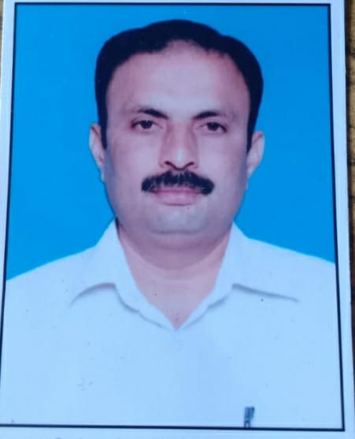

* B R Shivanna(ECONOMICS)

Head of Library Dept. GHS Rajanukunte

Education: MA, B.Ed

Date of Joining : 08/01/2018

Teaching Experience- 06 Years

Manjula V R (POLITICAL SCIENCE)

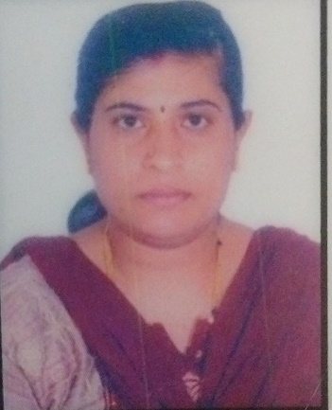Education:

Date of Joining- 05/07/2007

Teaching Experience- 17years

* Gouthami J K(SOCIOLOGY)

Head of NSS Club Dept.- Govt PU College Rajanukunte

Education:MA, B.Ed

Date of Joining- 01/07/2013

Teaching Experience- 11 Years

